Course ___Methods_Test 4_ Year __12_______

Student name: ________________ Teacher name: ________________

Date: Weds 26 August

Task type: Response

Time allowed for this task: _____45______ mins

Number of questions: _____6______

Materials required: Calculator with CAS capability (to be provided by the student)

Standard items: Pens (blue/black preferred), pencils (including coloured), sharpener, correction fluid/tape, eraser, ruler, highlighters

Special items: Drawing instruments, templates, notes on one unfolded sheet of
A4 paper, and up to three calculators approved for use in the WACE examinations

Marks available: __46____ marks

Task weighting: __10__%

Formula sheet provided: Yes

Note: All part questions worth more than 2 marks require working to obtain full marks.
Q1 (1, 1, 1 & 3 = 6 marks)
Consider a continuous random variable X that is uniformly distributed as follows.

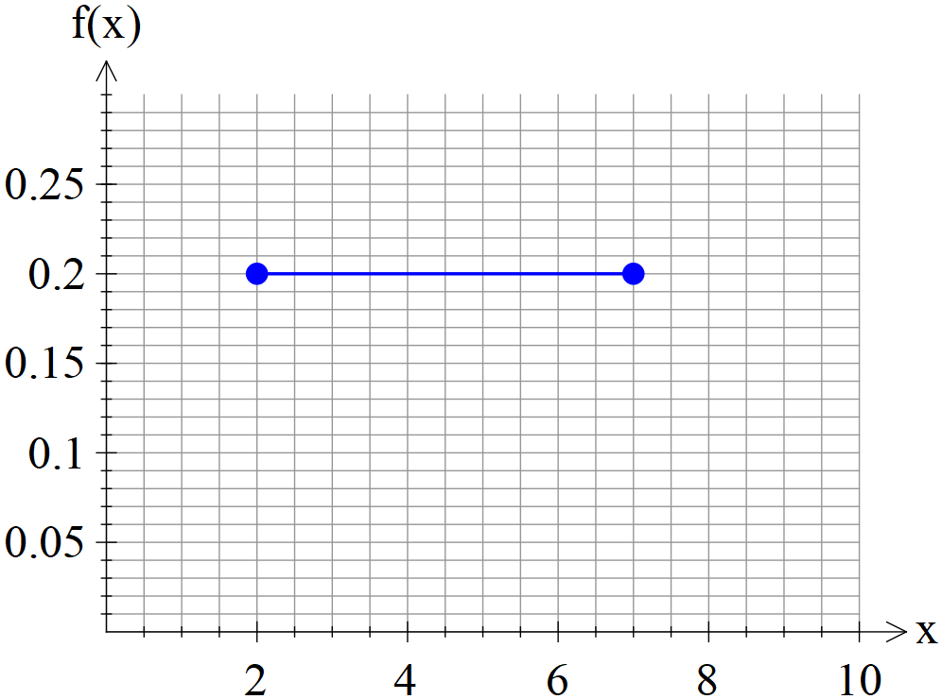

Determine the following:

Q2 (3 marks)
Consider a continuous random variable X shown below.
Solve for the constant exactly. (Show all working)

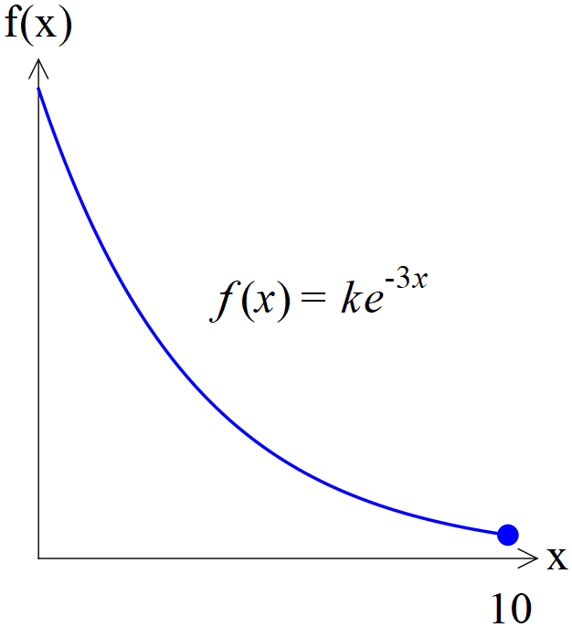

Q3 (1 , 4, 1 & 2 = 8 marks)
Consider a continuous random variable X shown below. (Not drawn to scale)
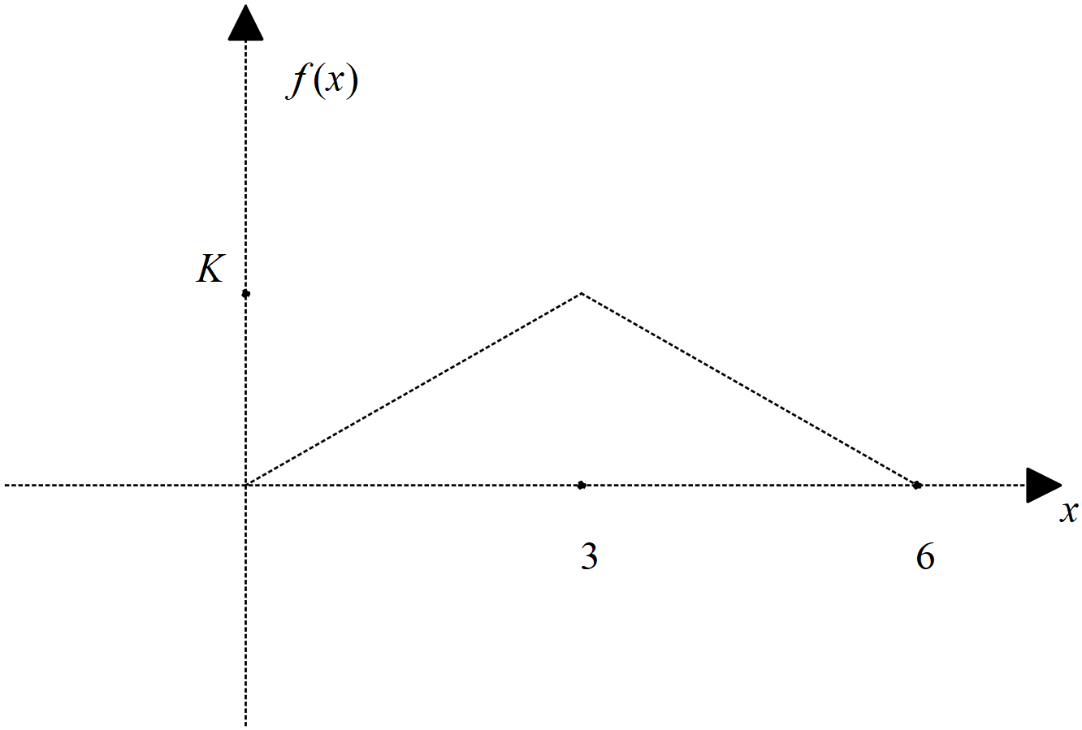

- Determine the value of the constant .

- Determine

- Determine

- Determine Standard deviation of

Q4 (2, 2 ,2 & 1 = 7 marks)
A continuous random variable, has a pdf
Determine:

- Standard deviation

Q5 (2, 2, 2 & 3 =9 marks)
The results for a class test, can be modelled by a Normal Distribution given by .
Determine:
- The 78th percentile.

- The cut-off for an A grade given that this grade is only given to the top 20%.

- A second test is a Normal Distribution with a mean of 55. Given that the 58th percentile is 62, determine the standard deviation.

Q6 (3, 3, 3, 2 & 2 =13 marks)
The time it takes to be served at a supermarket checkout, seconds, can be modelled by a normal distribution as follows seconds. The assistant at the check out is paid according to the following scheme.

Time served
In seconds
Payment $P | $5 | $7 | $12 | $15 | $18
Probability
To 4 decimal places

- Fill in the probability line of the above table rounded to three decimal places.

- Determine the expected payment showing full working.

- Determine the variance of the payment showing full working.

- If the payments were all increased by 30% and a bonus of $2 added to each category, determine the new mean and standard deviation.

- Explain a limitation of the Normal distribution model and show a calculation to support this.

